Academic Year: 2025-26 | Year: Second Year | Semester: II
PRN No.: 1012411011 | Name: Riddhee Kulkarni
Subject: Python Programming
Assignment No.: 18
Date: 16/02/2026

Lab Assignment: 18
Aim:
Write a program to create their own module for a specific function.

Objective:
To understand how to create and use a user-defined module in Python within Jupyter Notebook.

Theory:
A module in Python is a file containing functions, variables, or classes that can be reused in other programs.
- Modules improve code reusability and organization.
- A user-defined module is created using a .py file.
- The module is imported using the import keyword.
- Functions are accessed using module_name.function_name().
In Jupyter Notebook, the %%writefile magic command is used to create a module file directly from a notebook cell.

Algorithm:
Part 1: Creating the Module
- Start the program.
- Use %%writefile to create a file named mymath.py.
- Define functions:
- add(a, b)
- subtract(a, b)
- multiply(a, b)
- divide(a, b)
- Save the file.
Part 2: Using the Module
- Import the created module.
- Enter two numbers.
- Call each function from the module.
- Display the results.
- Stop the program.

Pseudo Code:
START
CREATE module mymath
DEFINE add(a, b)
RETURN a + b

DEFINE subtract(a, b)
RETURN a - b

DEFINE multiply(a, b)
RETURN a * b

DEFINE divide(a, b)
IF b != 0
RETURN a / b
ELSE
RETURN error message
END MODULE

IMPORT mymath
READ num1, num2
PRINT add(num1, num2)
PRINT subtract(num1, num2)
PRINT multiply(num1, num2)
PRINT divide(num1, num2)
STOP

Code:
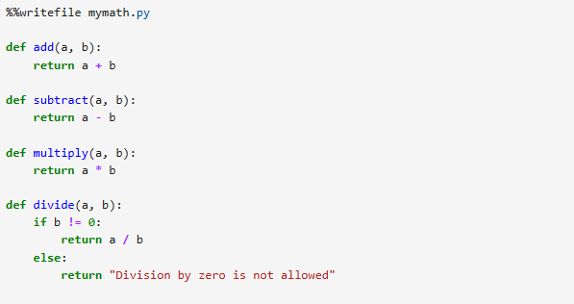
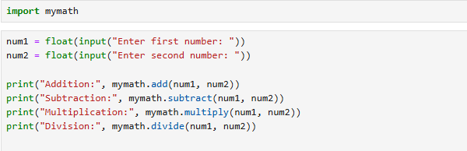

Output:
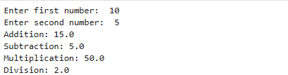

Conclusion:
Thus, a user-defined module was successfully created and used in Jupyter Notebook. The program performed addition, subtraction, multiplication, and division operations correctly, demonstrating modular programming and code reusability in Python.

